THE RIDE – THE FINAL CONCEPT ART + CHARACTER DESIGNS DETAILS
The idea begins with established shot of the castle of the ride.
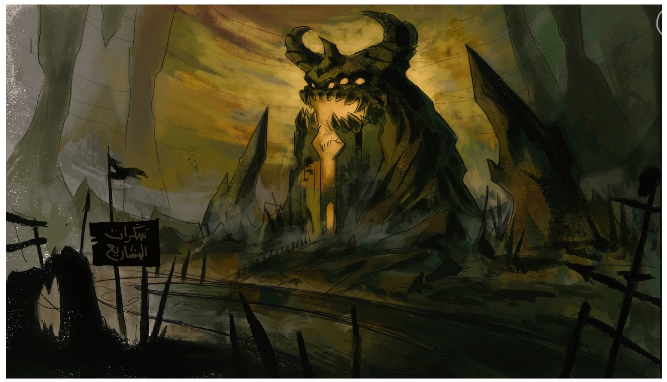

people in a big line ready to board a big ride,
two tall - big huge weird looking - gatekeeper opens the door to the line to start the ride and ^{enter} the door
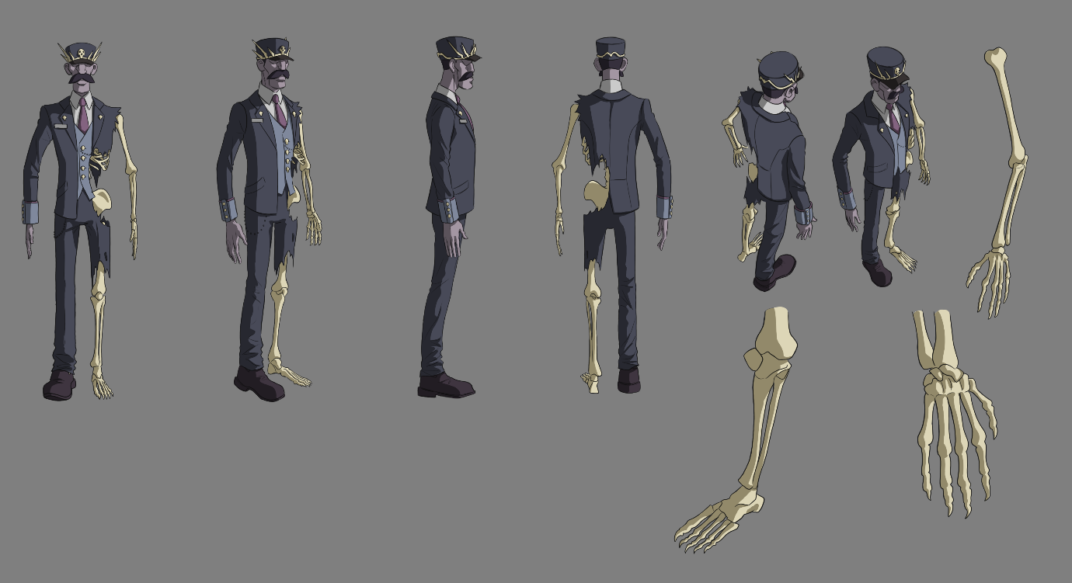
people are stressed as they enter the castle .
the main character with the other in the line
the main character variation –
the big doors opens :
the big door design
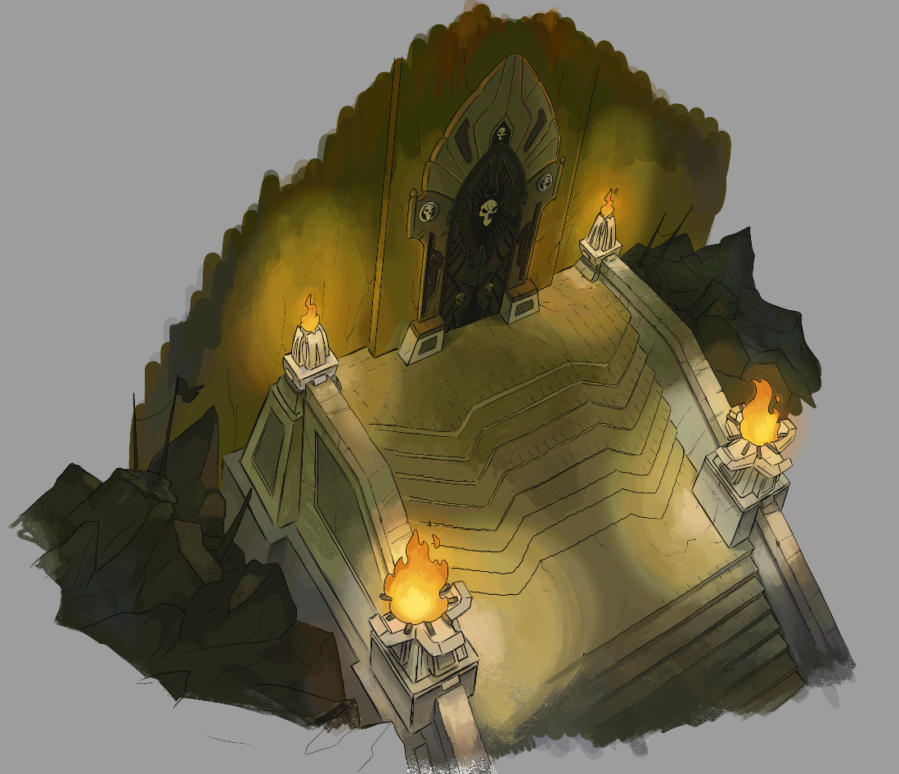
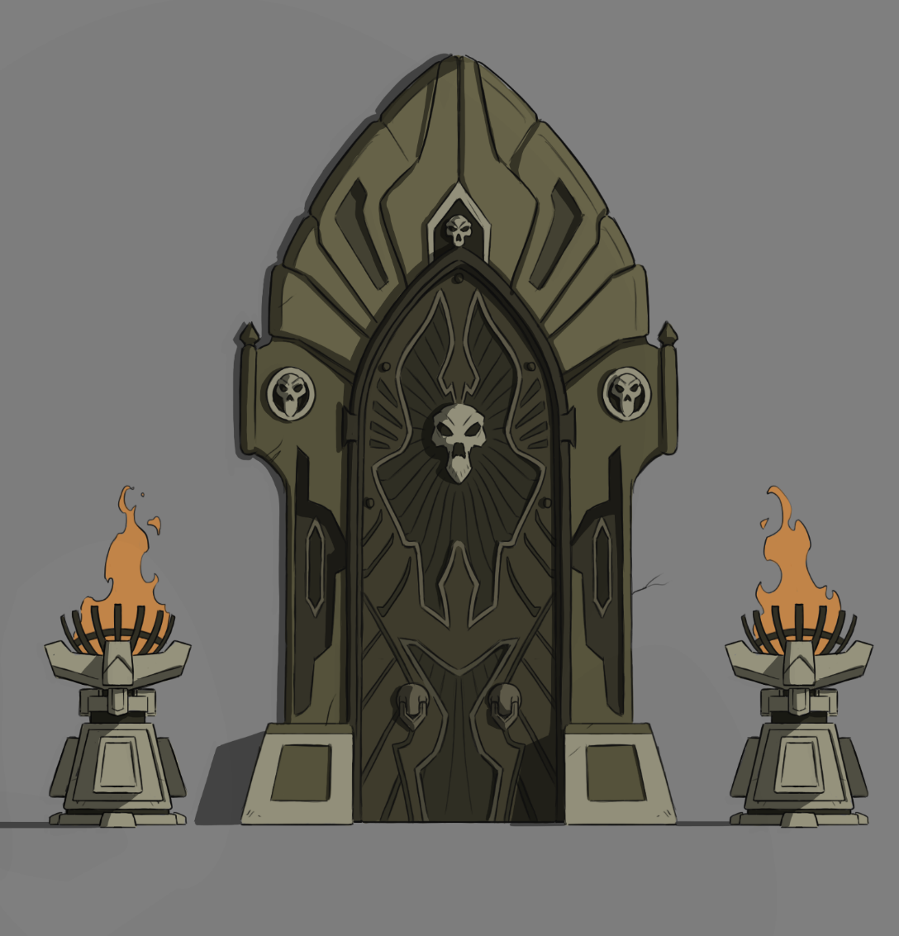

A few people along with our main character board the ride and as they move we are shown that they are going to enter a weird looking castle, and they are totally ignorant of what they are going to see.

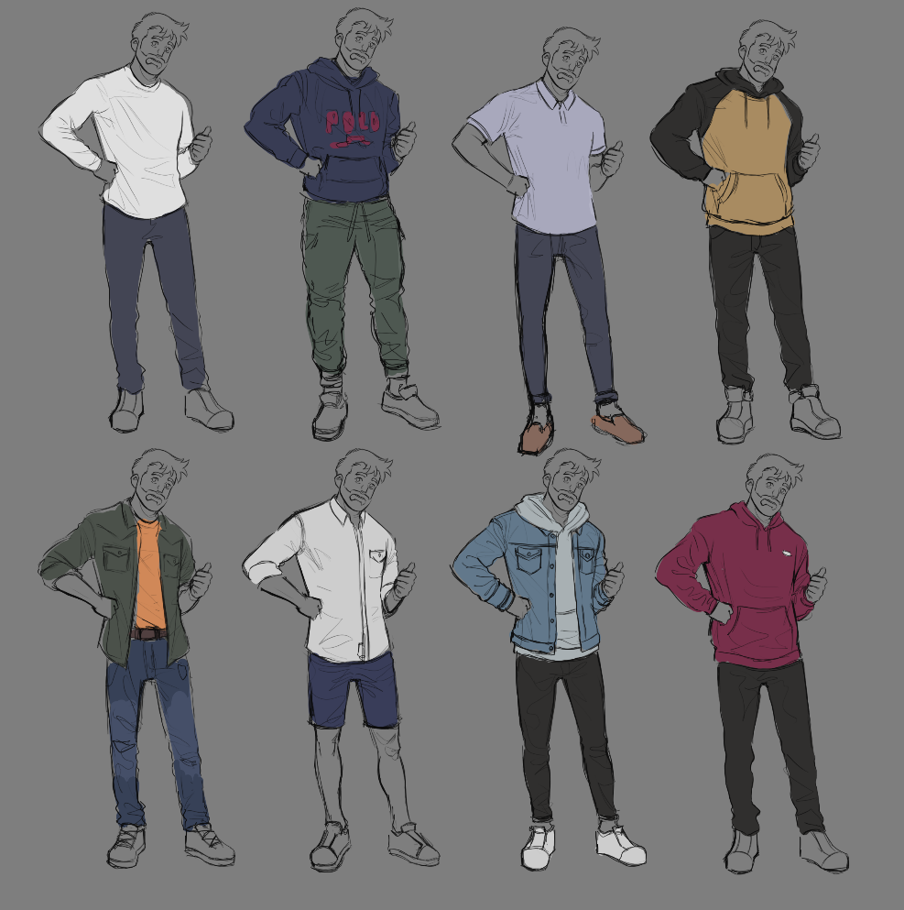

as they enter the castle they are going down through a weird stairway so that they can enter the ride
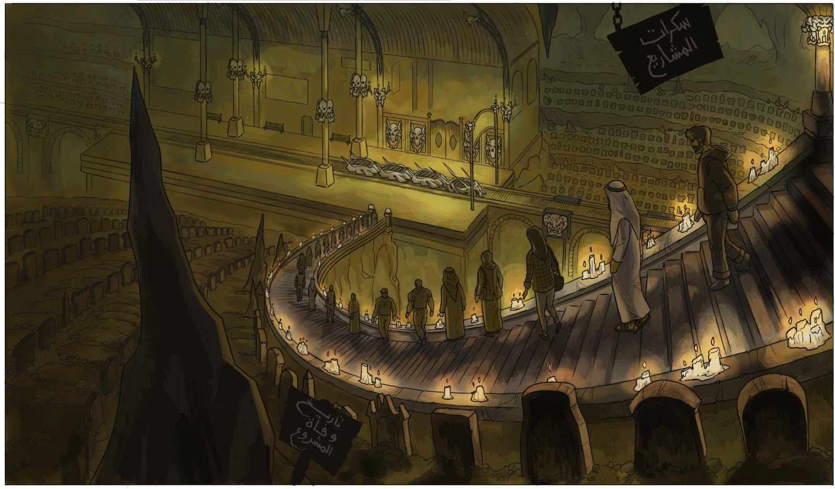
after the line they enter the ride and the panels shows the start button .

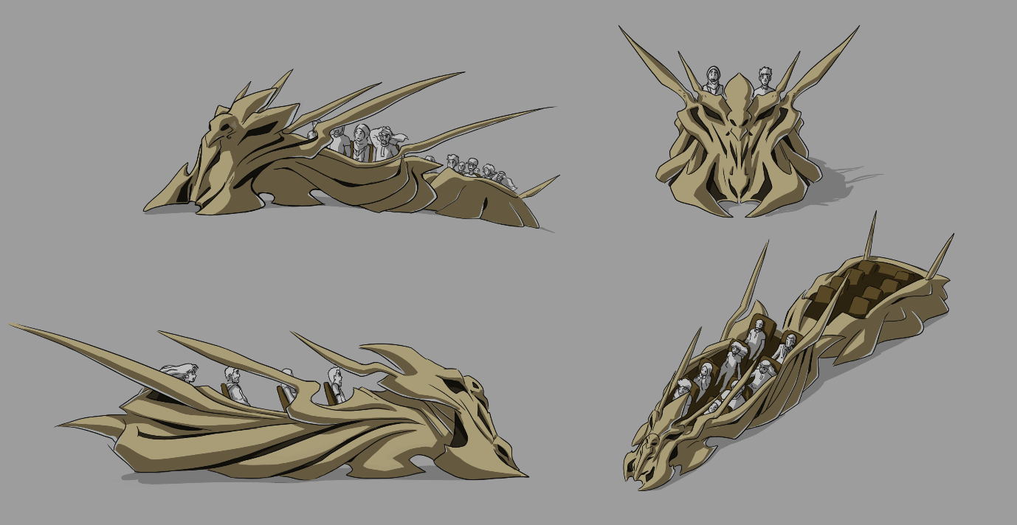

Narrator: who speaks like singing mentions “today is your day, you will see for yourself what happened to people similar like you”

As the ride progresses, there are hints that mentions that the depressed people they are seeing are business owners who took the wrong direction in marketing their business and ultimately landed in hell (which is hinted with weird backgrounds).
As the ride progresses the people in the ride sees graves on both sides (hints that they are business that perished due to wrong decisions). The people in the ride are now scared.
As they reach the first phase of the ride some people from the ride are pulled into the graves as the ride stops and the panel is showed again mentioning pull them to the graves

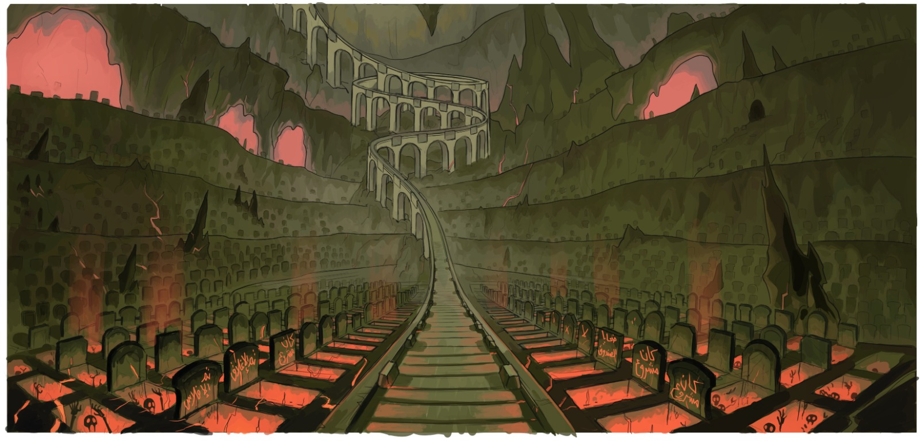

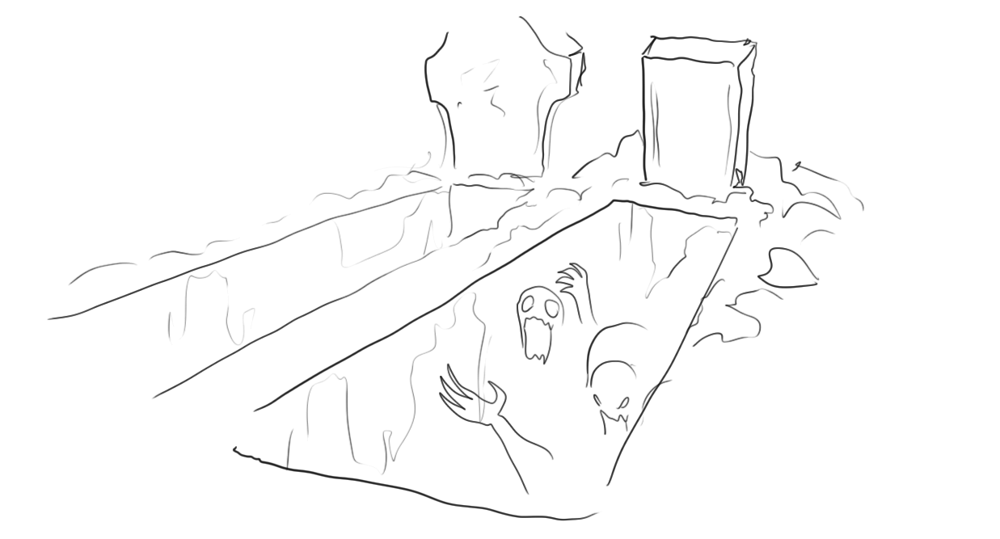

Then our talent will hit the start button again to run away from this phase going to the next hoping that it will be better .

When the talent arrives to the final phase which is the black market phase he will see the huge four landmarks with an agent protecting them from the public so that no one can touch those huge land mark
We can see the two first landmarks with their agents that the agents are holding some slaves to let them attack any one will come to this phase:

The agent:

The middle one:

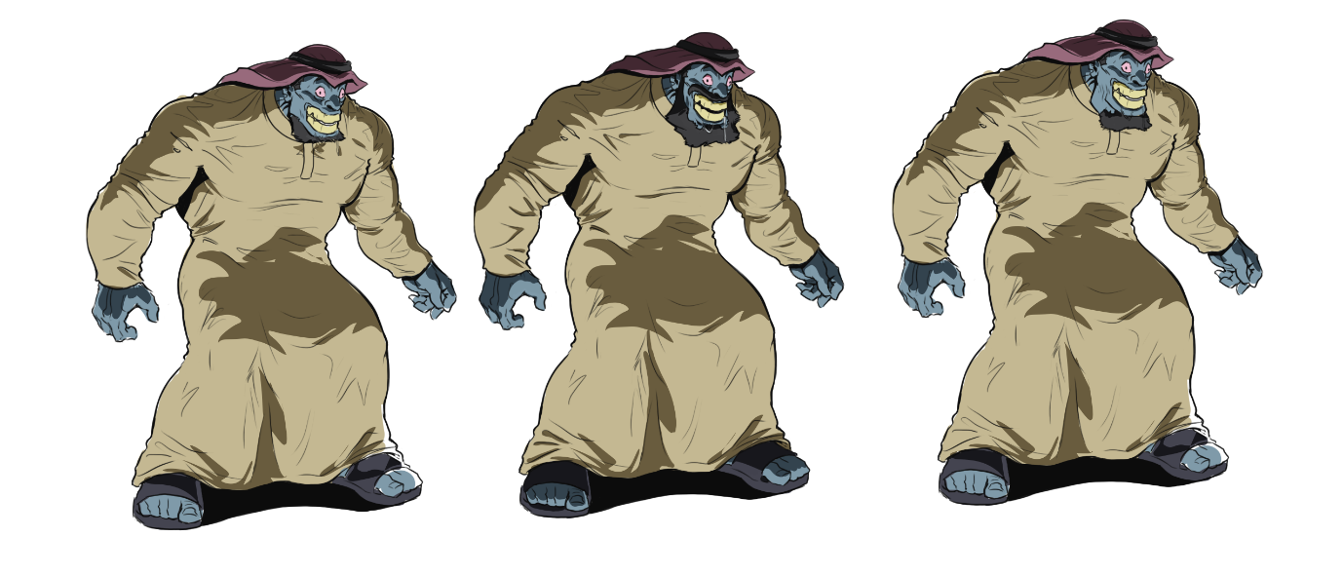
the agents with their slaves :

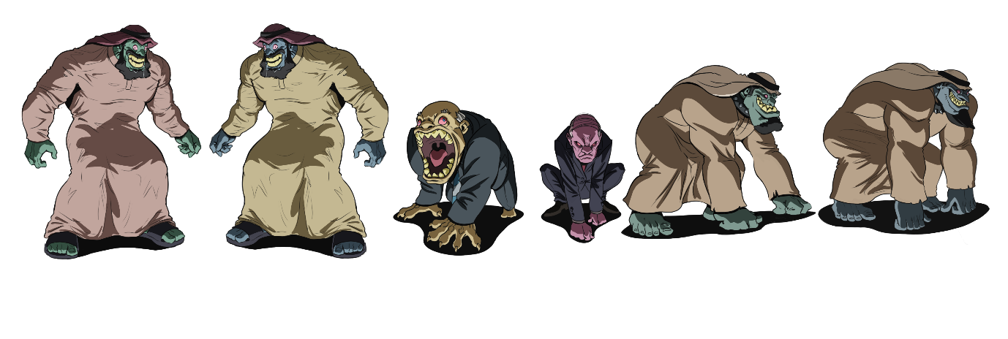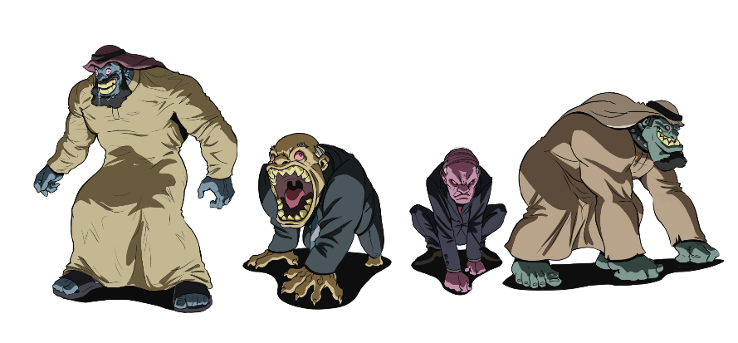
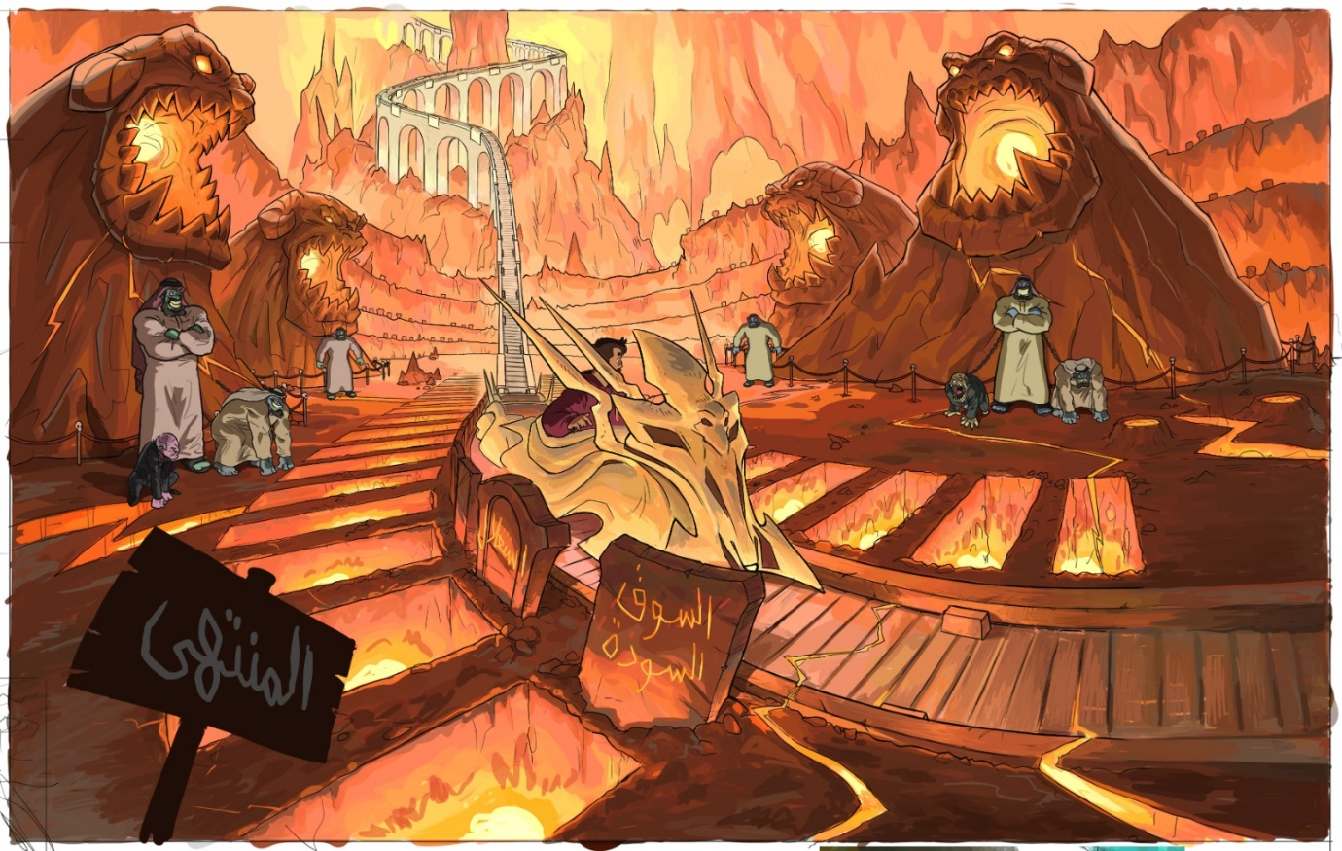
Narrator: “they will squeeze out your life, suck out each penny that you have and will then come after you to grab all” (hinting that the people after them are the influencers and the marketing agents who are just after their money and they care about nothing else) At this point the main character with great effort tries to move the coaster and escapes from that area and as he progresses
panels shows that the agents and slaves are ready to attack, then they follow the talent to attack
both right and left showing agents with the fire rock and in the middle one slave they all attack
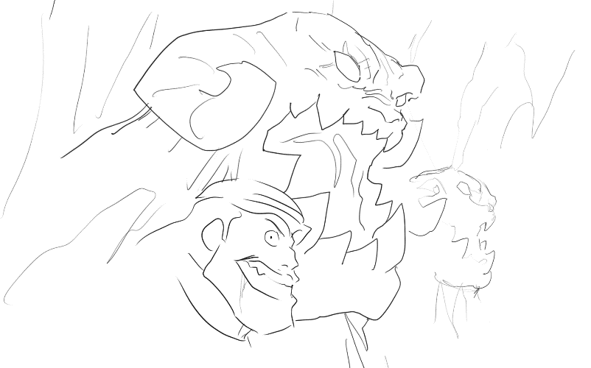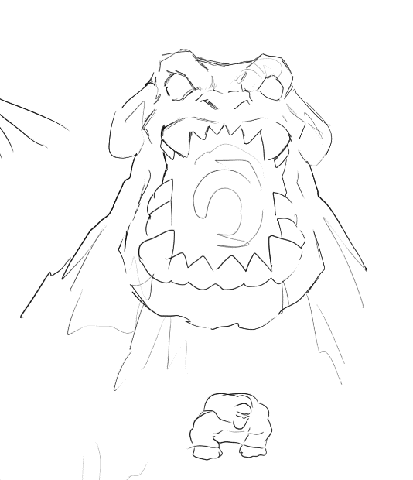
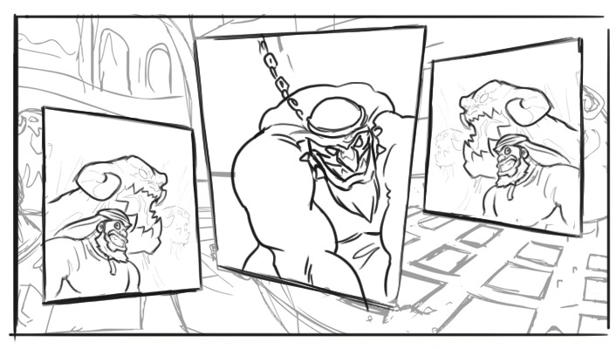
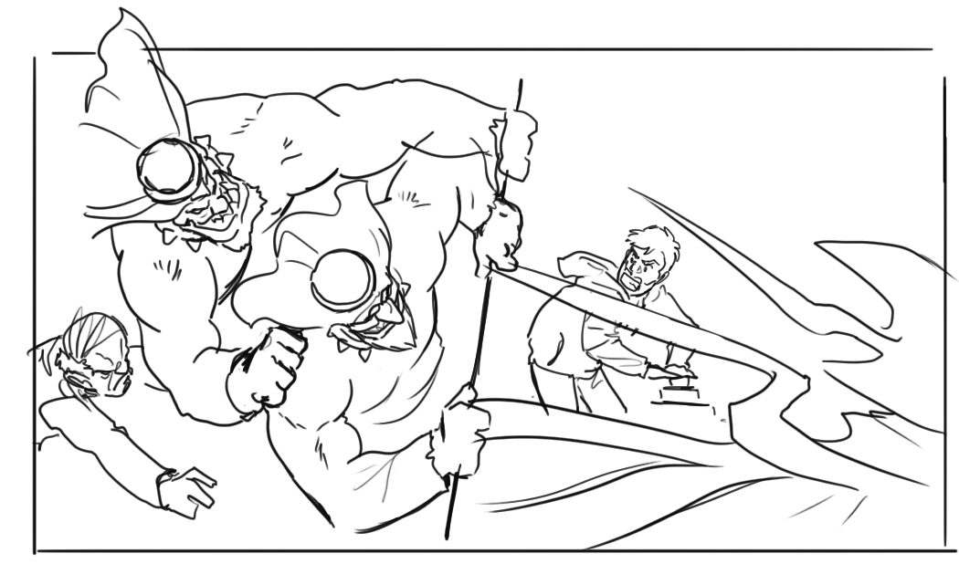

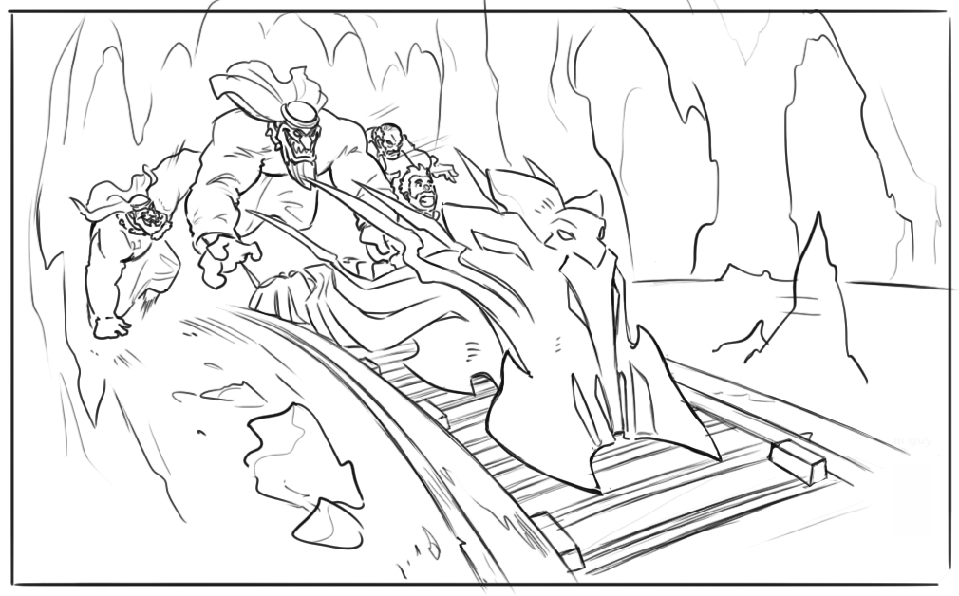
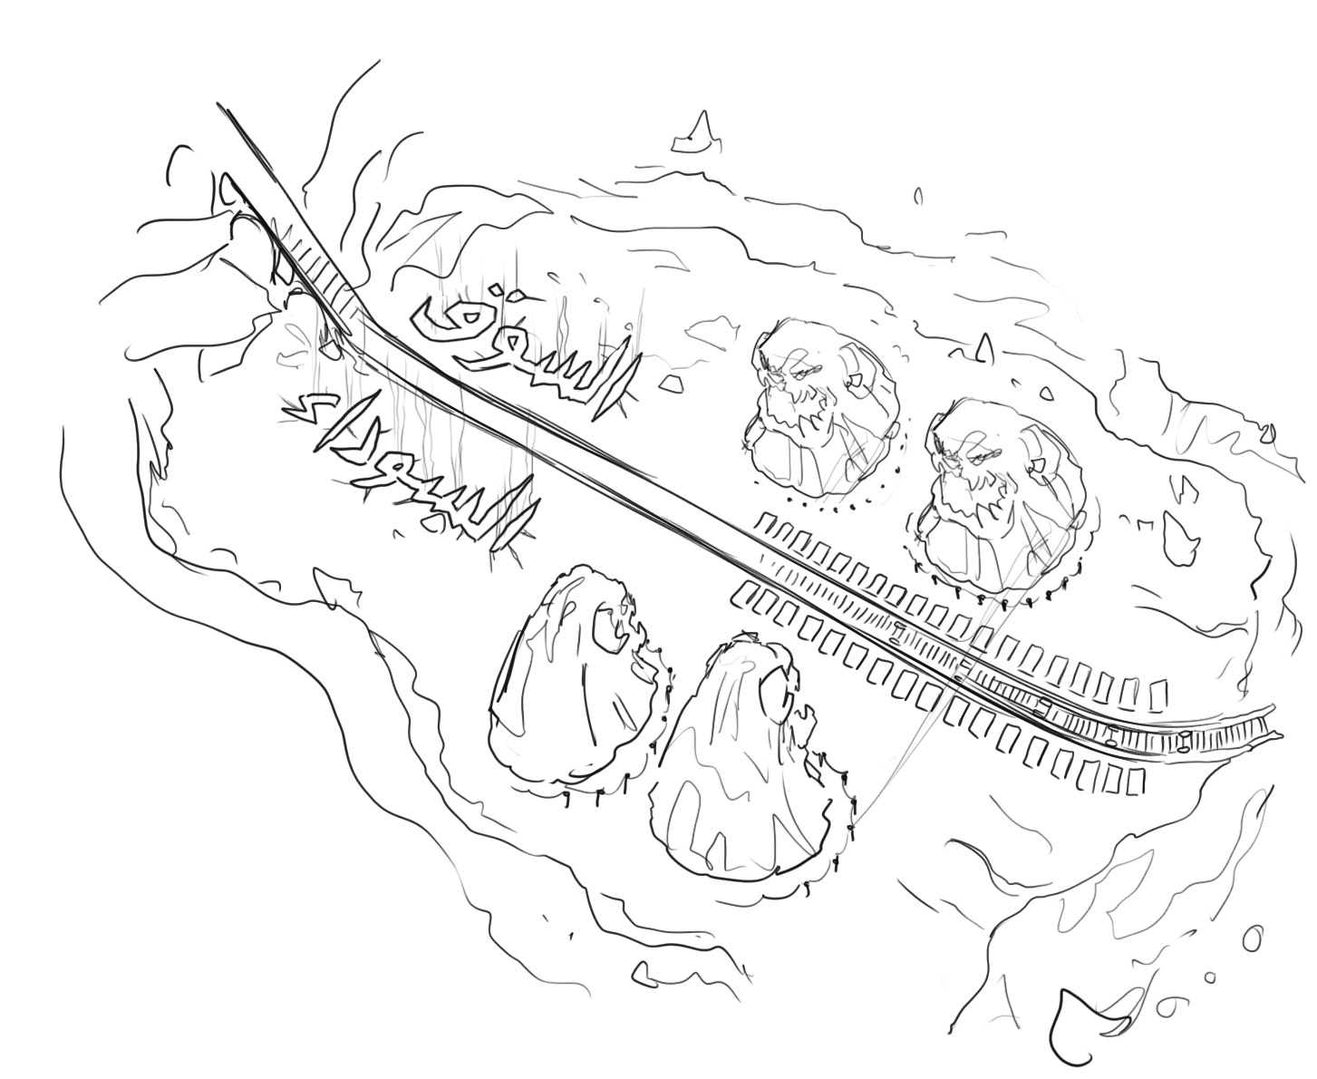
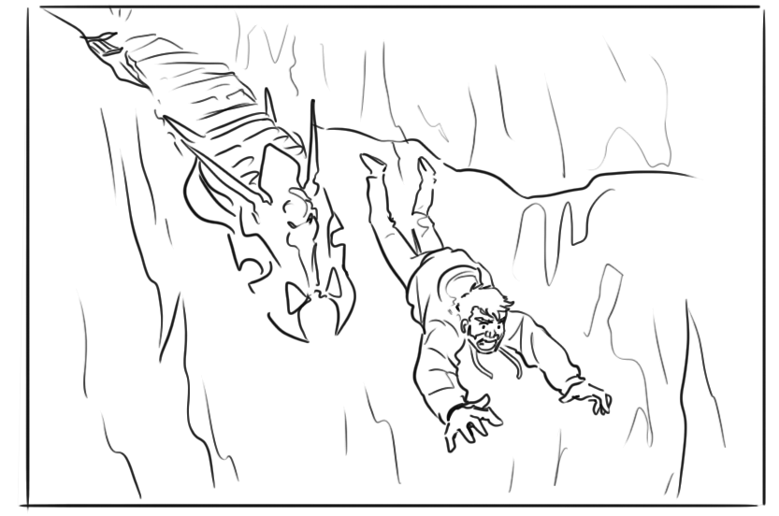
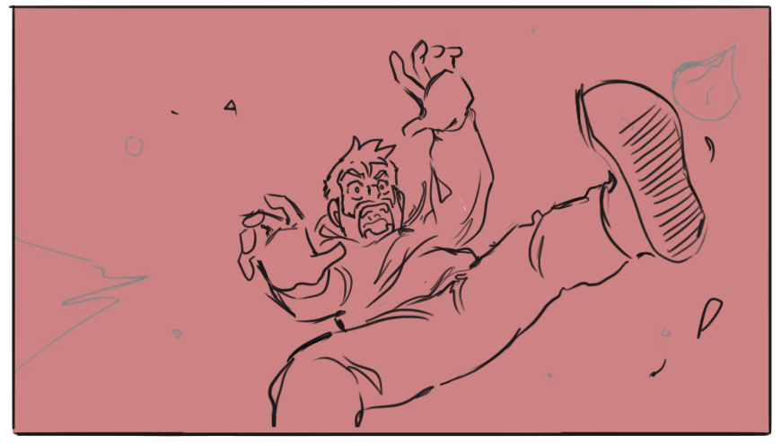

he reaches a place like the land of doom, he understands there is no escape from this place and he falls into the fire of hell.
At this very point our mascot the digital superwoman comes flying holds our character and flies away into a land that looks similar to heaven.

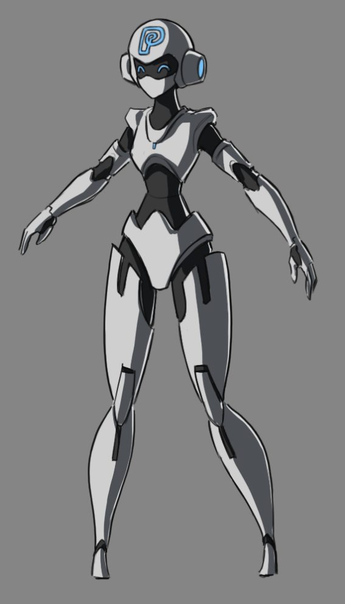
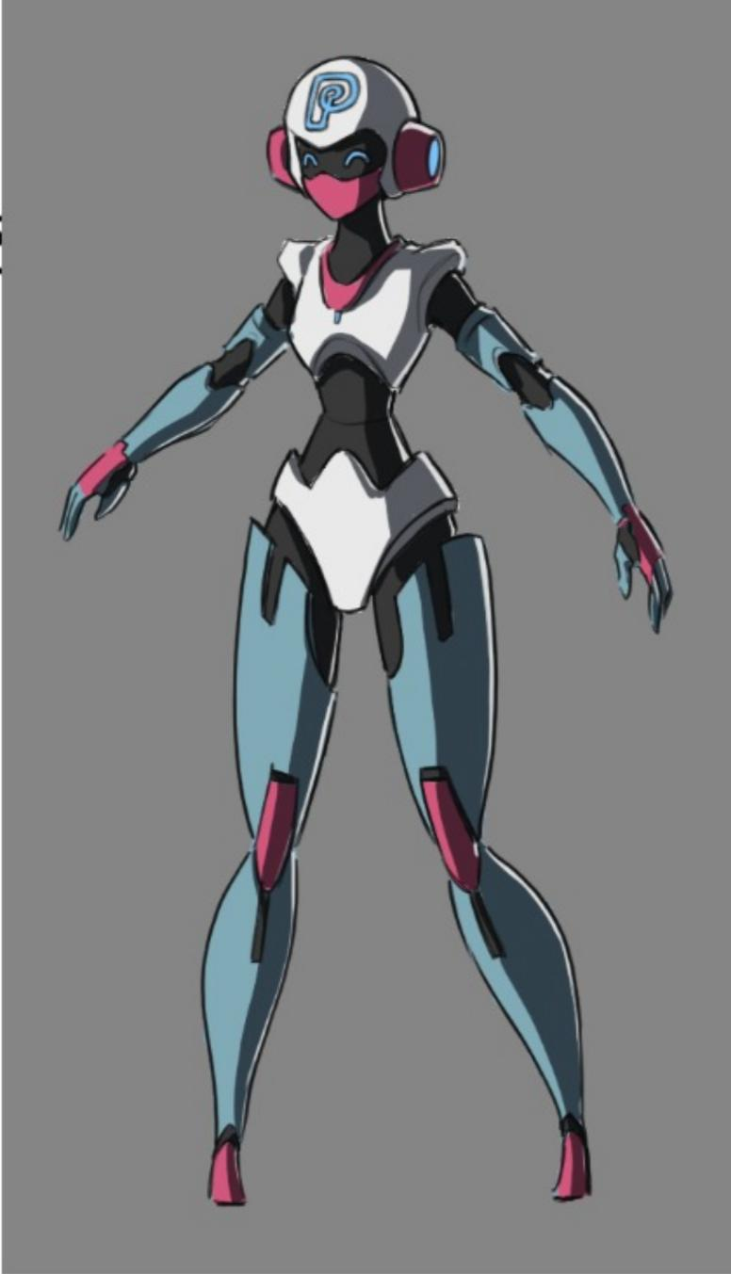
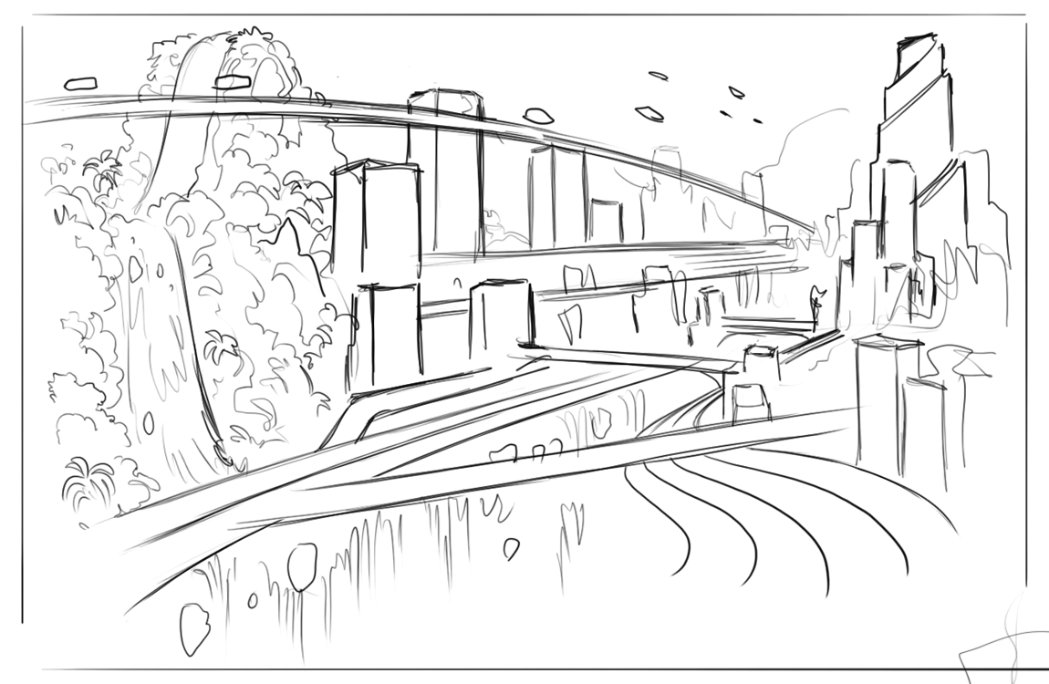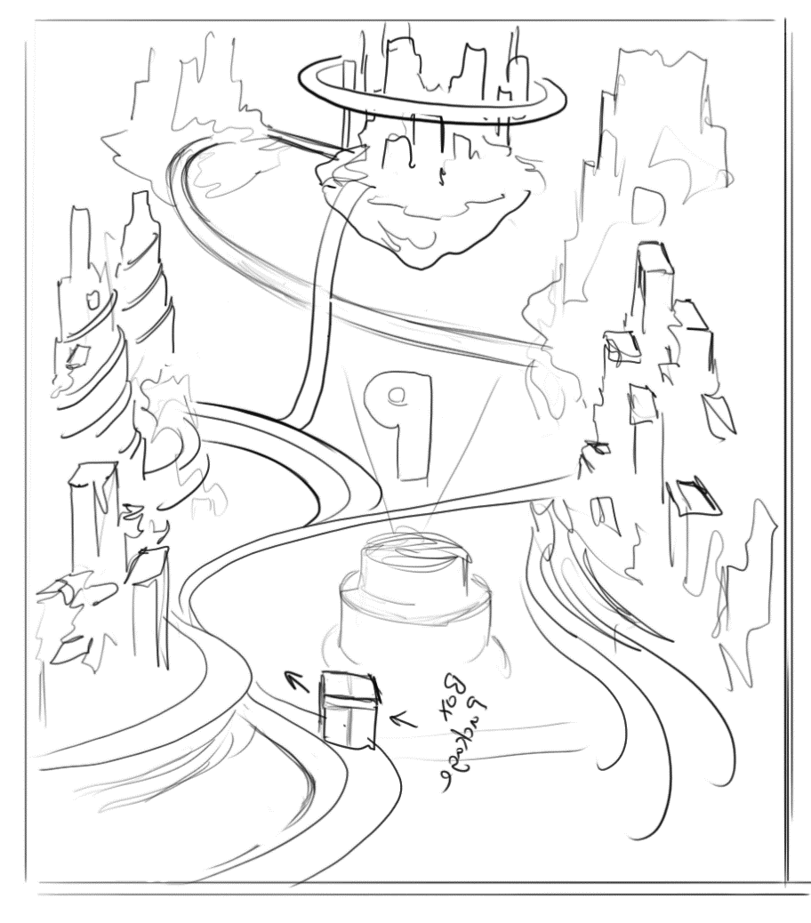

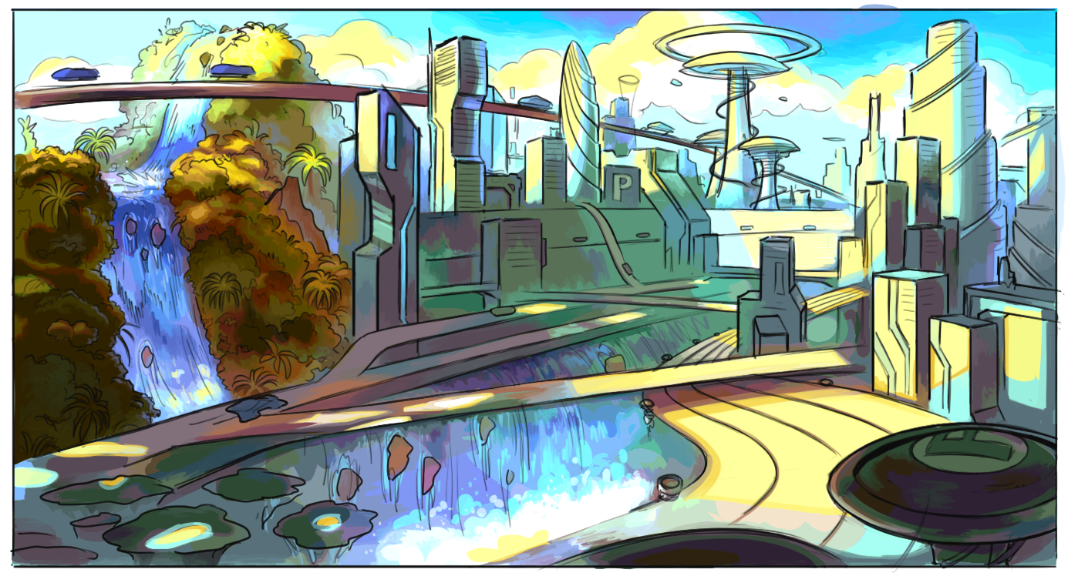

Here the mascot reveals that he is safe and can do his business needs in a symmetrical straight forward manner without being cheated; and mentioning this hands him a phone.
As soon as he receives the mobile he clicks on it and then things move so symmetrically organised that the business gets refined. A box from the mobile goes to all the influencers and it is a happy vibe.
Business gets prosperous and there is a celebration mood.
Mascot and the character reveal the mobile and the app icon and share the fact.

